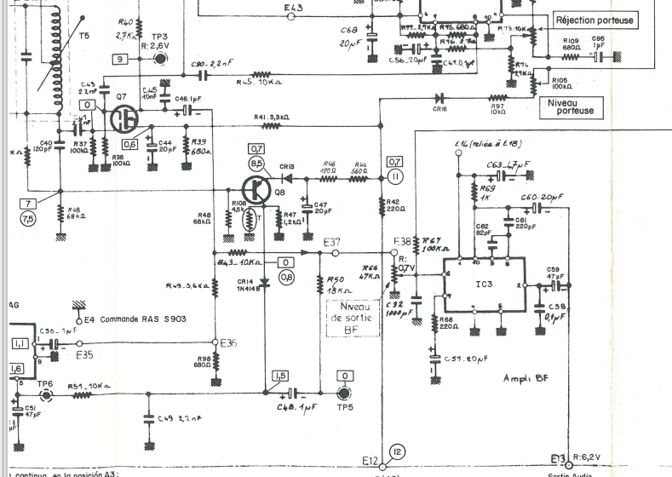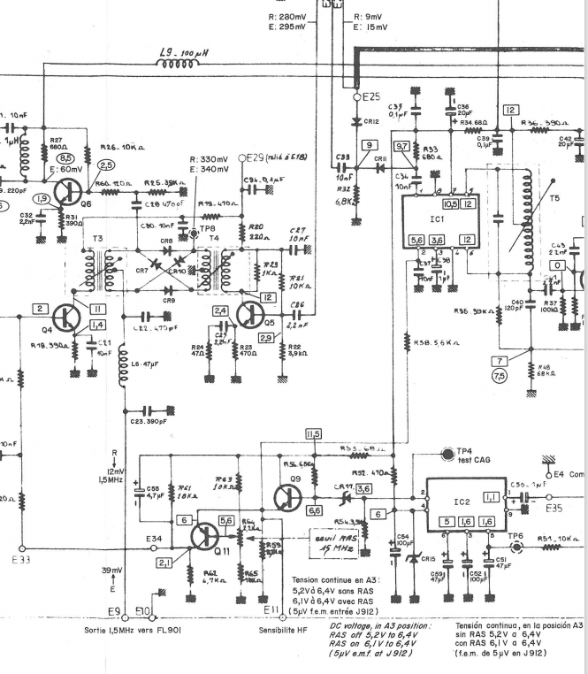

Ic2 - SL621C
Ic3 - TAA611
Ic1 - MC1590G

